108208004 經濟三 白植允

Homework 1

#1

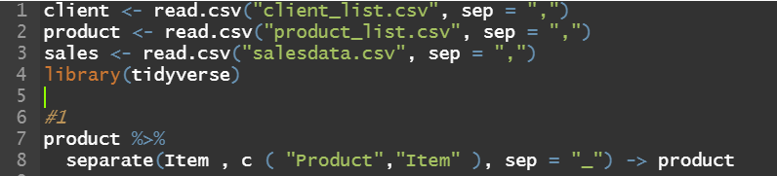

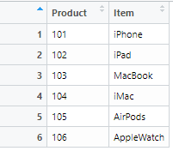

#2



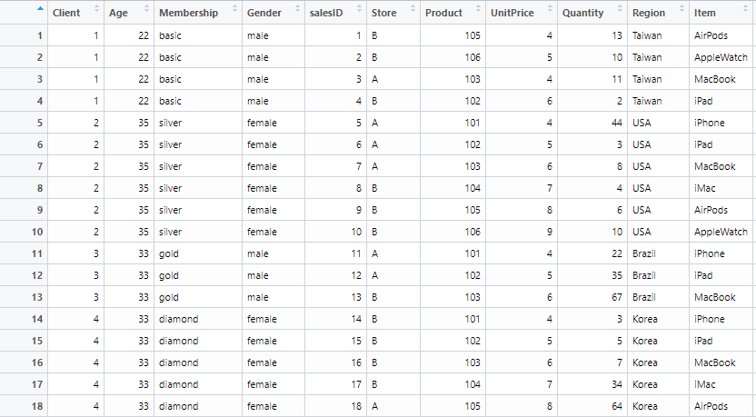

#3



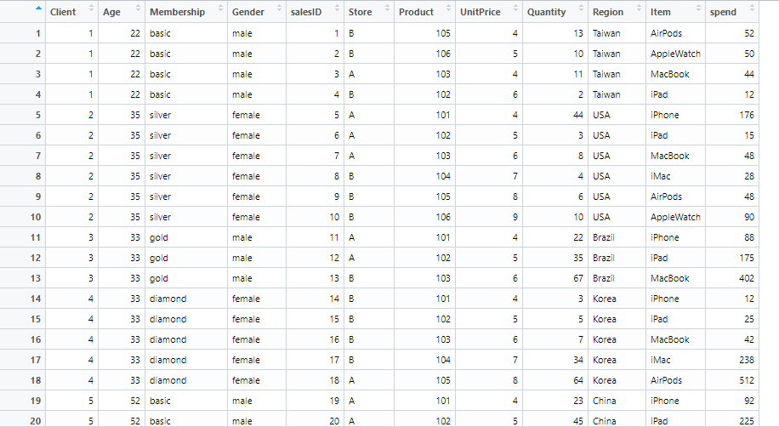

#4

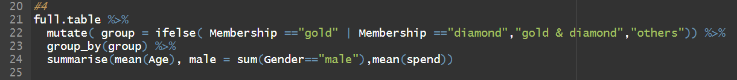

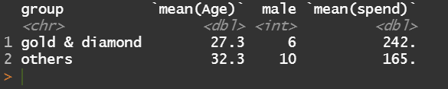

由分析可知gold&diamond組的平均年紀、平均消費較高，男性會員較少

#5

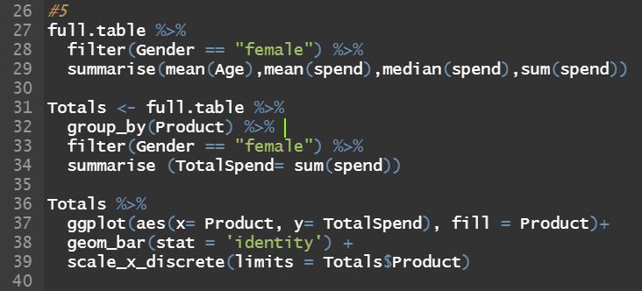

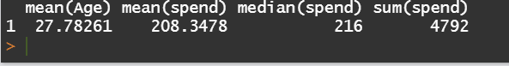

可知女性客戶的平均年齡約27歲，平均消費約208元，總消費額4792元

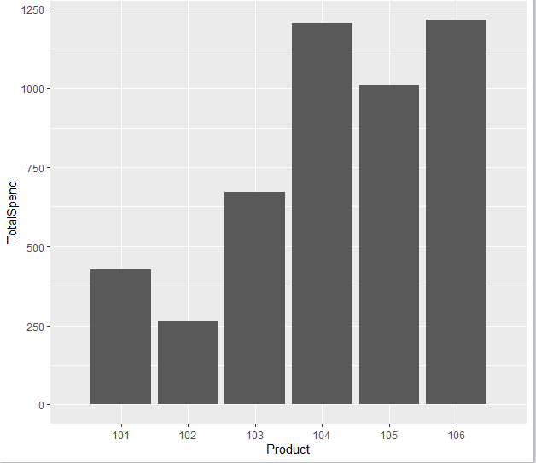

由涂可知女性花在產品106和104的錢最多，102的最少

* 程式碼

client <- read.csv("client_list.csv", sep = ",")

product <- read.csv("product_list.csv", sep = ",")

sales <- read.csv("salesdata.csv", sep = ",")

library(tidyverse)

#1

product %>%

separate(Item , c ( "Product","Item" ), sep = "_") -> product

#2

product$Product <- as.numeric(product$Product)

full.table <- client %>%

inner_join(sales) %>%

inner_join( product)

#3

full.table %>%

mutate( spend = UnitPrice * Quantity) -> full.table

#4

full.table %>%

mutate( group = ifelse( Membership =="gold" | Membership =="diamond","gold & diamond","others")) %>%

group_by(group) %>%

summarise(mean(Age), male = sum(Gender=="male"),mean(spend))

#5

full.table %>%

filter(Gender == "female") %>%

summarise(mean(Age),mean(spend),median(spend),sum(spend))

Totals <- full.table %>%

group_by(Product) %>%

filter(Gender == "female") %>%

summarise (TotalSpend= sum(spend))

Totals %>%

ggplot(aes(x= Product, y= TotalSpend), fill = Product)+

geom_bar(stat = 'identity') +

scale_x_discrete(limits = Totals$Product)